Display Screen Equipment (DSE) Assessment

Company Name:
Workstation location/Department:
Checklist completed by:
Assessment checked by:
Date of assessment:
Office use only! | YES | NO
Any further action needed?
Follow up action completed on:

Work through the assessment checklist, indicating ether ‘Yes’ or No’ against each question.

Information relevant to each subject heading is provided, and you are encouraged to make adjustments to your workstation set-up/work space in line with the guidance detailed (where this is feasible) prior to answering the question posed.

Any additional concerns/queries you may have relating to your workstation not covered in the individual subject headings can be detailed at the end of the assessment.

Completed assessments will be reviewed by the management team. A management team representative will liaise with you directly regarding any significant concerns.

Get Comfortable
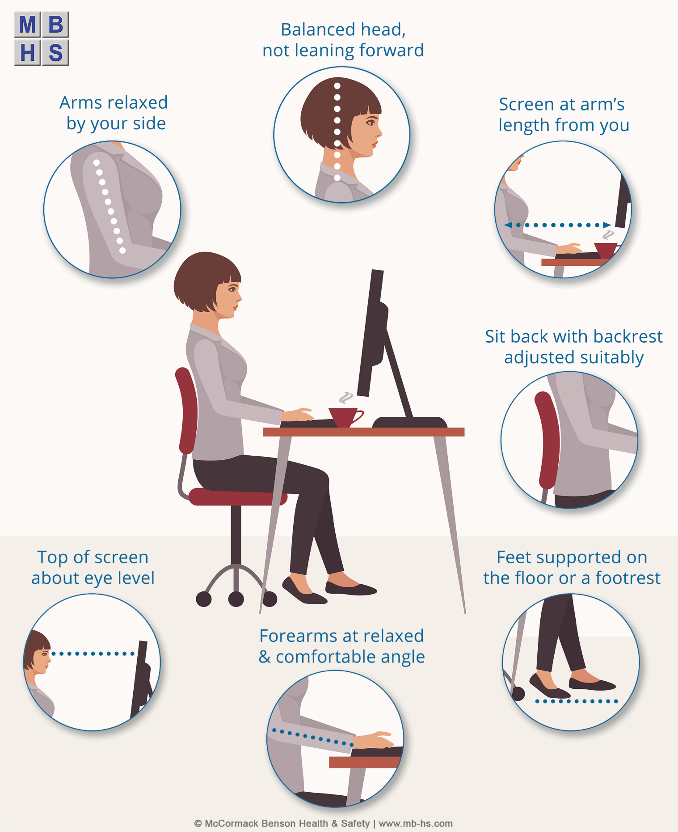

Display Screen
The characters on the screen should be clear and readable, and of adequate size. The screen should be kept clean and brightness and contrast settings adjusted to suit the ambient conditions.

The image on the screen should be stable, with no flickering or other forms of instability (e.g. jumping or jitter).

Your screen should have sufficient adjustment mechanisms to avoid glare and reflections and enable you to maintain a natural and relaxed posture. For laptop users, a separate keyboard, docking station or screen may be needed in order to maintain a comfortable viewing and keying position.

The screen should be free of reflective glare and reflections liable to cause discomfort. Adjust window coverings (where fitted), and/or adjust your screen accordingly.

Keeping your screen (and keyboard) clean will aid its legibility and increase your comfort.
 |  |  | YES | NO
Is your display screen satisfactory?

Keyboard
Your keyboard design should allow you to locate and activate keys quickly, accurately and without discomfort.

Hand support may be incorporated into the keyboard for support while keying or at rest, depending on what you find comfortable. Support can also be gained by leaving an adequate space between the keyboard and the front edge of your desk, or may be provided by a separate hand/wrist support on or attached to the work surface.

The symbols on the keys should be adequately contrasted and legible. Your keyboard should be kept clean. If characters can’t be read your keyboard may need modifying or replacing.
 |  |  | YES | NO
Is your keyboard satisfactory?

Mouse, Trackball etc. (‘pointing device’)
You should be able to easily use the device at your workstation, i.e. there should be enough space and you should be able to adopt a safe, comfortable working posture. For lengthy or repeated Laptop use, an external device should be used. The surface on which the device is used should allow it to work smoothly, a mouse mat may be needed if this is not the case.

In general it is important to place the device so that it is fairly close to your body. The aim is to avoid your arm becoming stretched out from the shoulder as if reaching. Aim to have your upper arm close to the side of your body with the elbow bent to approximately a right-angle. Your forearm or wrist should be supported by the work surface, or the elbow by the chair arm (if fitted). Your arm should feel reasonably relaxed.

It is also important to configure the speed and sensitivity of the device to suit you. The majority of standard office computer operating systems allow for various settings to be adjusted, you should familiarise yourself with these settings to ensure optimum comfort.

Most devices will require basic cleaning at some point, particularly those with moving parts (e.g. rollers). Materials can be provided for you to clean your device upon request.
 |  |  | YES | NO
Is your mouse/pointing device satisfactory?

Work Desk or Work Surface
There should be adequate space for you to find a comfortable position.

Your work desk or work surface should have a sufficiently large surface and allow flexible arrangement of the screen, keyboard, documents and related equipment. Personal belongings and other unneeded items (clutter) stored on your desk may hinder any scope for flexible arrangement.
 |  |  | YES | NO
Does your work desk or work surface allow you to achieve a comfortable position?

Work Chair
The primary requirement is that your work chair allows you to achieve a comfortable position.

Seat height adjustments should accommodate your needs for the tasks performed. The seat should be adjustable in height (i.e. relative to the ground) and the seat back to be adjustable in height (also relative to the ground) and tilt. Provided your chair design meets these requirements and allows you to achieve a comfortable posture, it is not necessary for the height or tilt of the seat back to be adjustable independently of the seat.

If your chair has arms, check that they do not interfere with your freedom of movement, for example by stopping you getting the chair under the work surface to sit comfortably at the keyboard.

A footrest may be necessary where you are unable to rest your feet flat on the floor. Footrests should not be used when they are not necessary as this can result in poor posture.

If you need training on how to adjust your chair, please ask!
 |  |  | YES | NO
Does your work chair allow you to achieve a comfortable position?

Environment
The following questions are aimed at establishing the general suitability of your individual working environment/work space.

By indicating ‘Yes’, you agree, in relation to your workstation, that the arrangements detailed under each subject heading have been met, and that no adverse effects are suffered/encountered?
 |  |  | YES | NO
Space Requirements
Prolonged sitting in a static position can be harmful. Support surfaces for display screen and other equipment and materials used at my workstation allow adequate clearance for postural changes, i.e. adequate clearances for thighs, knees, lower legs and feet under the work surface and between furniture components. There is sufficient space for me to sit down and get up without difficulty.
Lighting
Lighting is appropriate for all the tasks performed at my workstation. General lighting, by artificial or natural light, or a combination, illuminates the entire work room/work space to an adequate standard.
Reflections and Glare
My workstation set-up is such that windows and other openings, transparent or translucid walls, and brightly coloured fixtures or walls cause no direct glare or distracting reflections on the screen or other parts of the workstation.
I understand that, where fitted, curtains or blinds should be adjusted to prevent unwanted light.
Noise
Noise from equipment such as printers at display screen workstations is kept to levels which does not impair my concentration or prevent normal conversation (unless the noise is designed to attract attention, for example to warn of a malfunction).
Heat and Humidity
Electronic equipment can be a source of dry heat which can modify the thermal environment at the workstation. Ventilation and humidity is maintained at levels which prevent discomfort and problems of sore eyes.

Software
The Company endeavours to select and use software appropriate to its operational needs, which includes the tasks you carry out. In most circumstances software will allow an element of personal control/adaption to suit your individual preferences, i.e. larger than standard text, background colours etc.

You are encouraged to speak with a member of the IT Department/management team if you are experiencing difficulties with the chosen software, or, believe it can be modified to suit your individual needs. Software should respond quickly and clearly to your input, however, from time-to-time software may lag/not work as intended, resulting in frustration. If such a problem persists, please seek assistance.
 |  |  | YES | NO
Does the software you are required to work with provide trouble-free use?

Additional Information
The Company understands that the principal health risks associated with DSE work are physical (musculoskeletal) problems, visual fatigue and mental stress. These problems often reflect bodily fatigue. None of them are unique to DSE work, nor are they an inevitable consequence of it. Risks to typical users should be low if the DSE Regulations are complied with and ergonomic principles are taken into account in the design, selection, installation and use of the equipment; the design of the workplace; and the organisation of the task.

Eye and Eyesight testing

If you are deemed to be a ‘user’ of display screen equipment you are entitled, upon request, to an appropriate eye and eyesight test (sight test). ‘Special’ corrective appliances (normally spectacles) provided to meet the requirements of the Health and Safety (Display Screen Equipment) Regulations will be those appliances prescribed to correct vision defects at the viewing distance or distances used specifically for the display screen work concerned.

The provision of eye and eyesight tests and of special corrective appliances under the Health and Safety (Display Screen Equipment) Regulations is at the expense of the Company. Further details can be obtained from the management team/HR.

Your responsibilities

As a Company we endeavour to implement arrangements to ensure a safe and healthy working environment.

We also expect you, as a user of display screen equipment, to take some personal responsibility for your own comfort and general wellbeing, this includes: maintaining good posture, keeping your work space uncluttered and clean, bringing to the management’s attention any issue you believe compromises your health or safety, or indeed, any discomfort or symptoms you attribute to working with DSE.

One of the major contributory factors when suffering aches and pains that can be attributed to the use of DSE is its prolonged or repeated use. Don’t sit for long periods, regular movement is important. Get up from your chair 2-3 times an hour for 30-60 seconds or 5-10 minutes every hour and perform micro exercises (simple chair based movements) for 2 minutes in every hour.

Final Question
Please indicate your overall satisfaction with your workstation set-up/arrangements, i.e. suitability of IT equipment, furniture, general work space, task design? (tick one box)
1 | I’m happy with my DSE workstation set-up – no further action necessary
2 | I’m generally happy with my DSE workstation set-up, but may seek some additional help/advice
3 | Overall I’m content with my DSE workstation but could benefit from additional help, however, I suffer no pain or discomfort
4 | As a result of using my DSE workstation I suffer aches and pains occasionally and would benefit from some additional help
5 | I suffer significant pain/discomfort when I use my DSE workstation – I require further help!

If you have indicated either ‘4’ or ‘5’ above, describe briefly the nature of the discomfort/pain suffered? This space can also be used to detail any other problems you may have working with your DSE.

